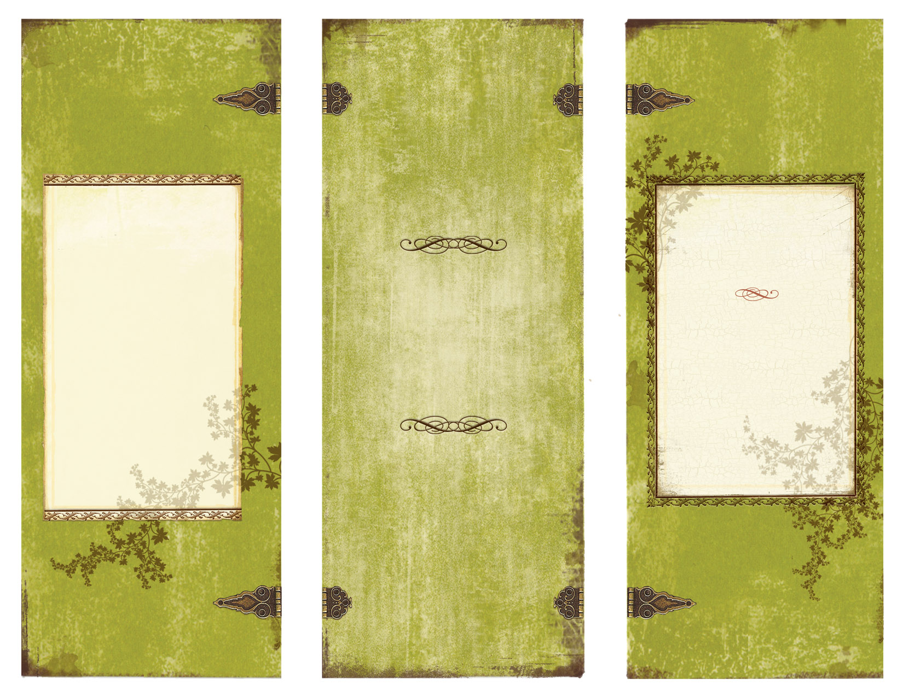
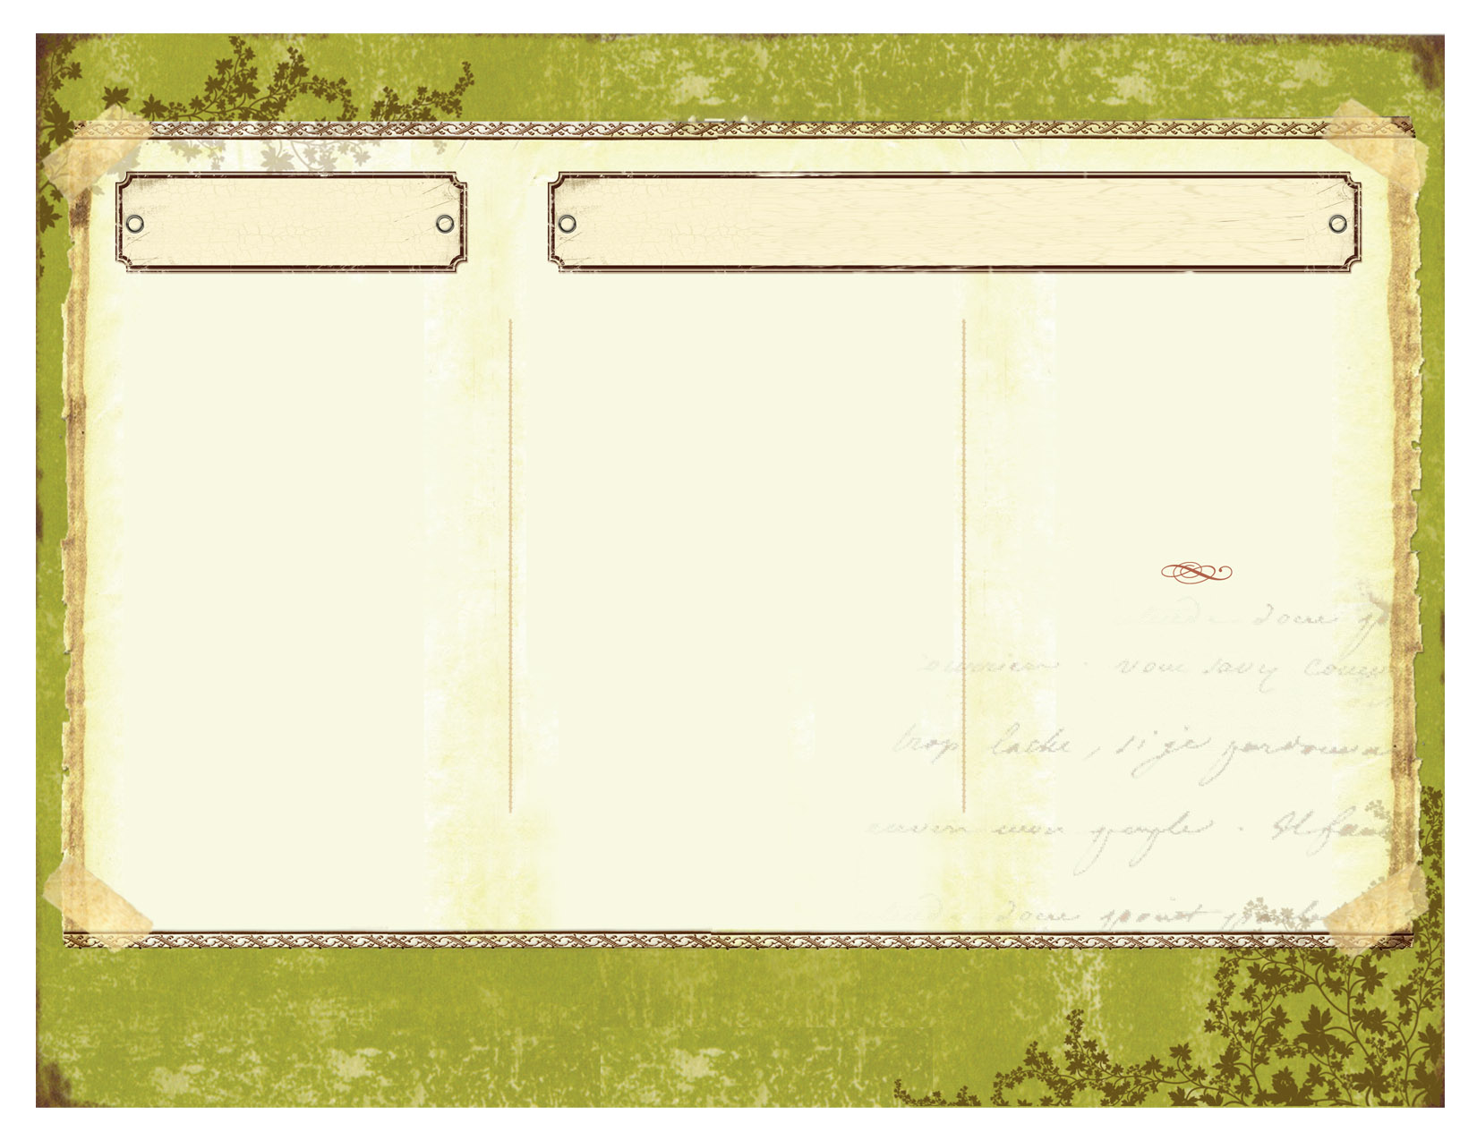

Contact Us

*Phone: 618-559-7574 (Angie)

Email: bourbontrail@yahoo.com

A schedule of our upcoming events can be found at
www.facebook.com/bourbon.trail
www.bourbontrail.yolasite.com

*The best way to reach us is by phone*

Based on length of performance and distance of performance.
Full Band
$700 – $900 for a 4 - 5 hour performance.
Acoustic
$100 per hour

Rates
Musical Entertainment Services
Bourbon Trail
BT
Bourbon Trail

Ph 555.555.5555
Fx 555.555.5555

5555 Street Address
City, State 55555
We have drawn the attention of venues in Edwardsville, Springfield, Taylorville, Nashville, Okawville, Addieville, Aviston, Carterville, Collinsville, Mascoutah, Breese, Germantown, and Raymond, Illinois; our acoustic duo even made and appearance in Cody, Wyoming and Courtney has performed original compositions in Nashville, Tennessee.

We as a band value not only our music, but the people we entertain, the individuals who hire us, and those who support us as well. We enjoy the opportunity to draw a crowd and involve them through singing, dancing, clapping, foot tapping, and having a good time; or even just providing something to sit back and listen to.
~~~
The members of the band include:
Courtney Groennert
Lead vocals, guitar, bass, song writer
From Nashville, IL and currently a music major at SIUE.

Angela Groennert
Lead vocals
From Nashville, IL and is a psychology alum from SIUE.
Kali Sabo
Bass guitar
From Hoyleton, IL and currently an English literature major at McKendree University.

Josh Beyers
Drums
From Taylorville, IL and currently a music major at SIUE.

Garrett Rongey
Guitar
From Edwardsville, IL and currently a music major at SIUE.

Dan Cluphf
Guitar and vocals
From Maryville, IL and currently a business major at SIUE.

Robert Cange
Fiddle, mandolin, and vocals
From Edwardsville, IL and is planning to pursue a career in law enforcement.

Continue brochure text here. Continue brochure text here. Continue brochure text here. Continue brochure text here. Continue brochure text here. Continue brochure text here. Continue brochure text here. Continue brochure text here. Continue brochure text here. Continue brochure text here. Continue brochure text here. Continue brochure text here. Continue brochure text here. Continue brochure text here.

Continue brochure text here. Continue brochure text here.

We are Bourbon Trail, a band from Edwardsville, Illinois. Country music, older and recent, is our predominant genre but we also incorporate classic rock, easy listening, folk, and original pieces into our repertoire.

We are a seven member band and play for a variety of events and venues such as bars, weddings, dances, wineries, hotel lounges, private parties and events, and various others.

We also offer acoustic performances consisting of two to three members, involving vocals, an acoustic guitar, and occasionally a violin for a more relaxed, quiet atmosphere.

About Us ~ Members
The Band

